DLD LAB 07 SUBMISSION:
Name : Yash Raj
Roll Number: 24k-0737
Task#1:
Truth Table:
A1 | A2 | B1 | B0 | L(A<B) | E(A=B) | G(A>B)
0 | 0 | 0 | 0 | 0 | 1 | 0
0 | 0 | 0 | 1 | 1 | 0 | 0
0 | 0 | 1 | 0 | 1 | 0 | 0
0 | 0 | 1 | 1 | 1 | 0 | 0
0 | 1 | 0 | 0 | 0 | 0 | 1
0 | 1 | 0 | 1 | 0 | 1 | 0
0 | 1 | 1 | 0 | 1 | 0 | 0
0 | 1 | 1 | 1 | 1 | 0 | 0
1 | 0 | 0 | 0 | 0 | 0 | 1
1 | 0 | 0 | 1 | 0 | 0 | 1
1 | 0 | 1 | 0 | 0 | 1 | 0
1 | 0 | 1 | 1 | 1 | 0 | 0
1 | 1 | 0 | 0 | 0 | 0 | 1
1 | 1 | 0 | 1 | 0 | 0 | 1
1 | 1 | 1 | 0 | 0 | 0 | 1
1 | 1 | 1 | 1 | 0 | 1 | 0

Simplified Expression:
- For A<B:
A1’B1 + A1’A2’B2’ + A2B1B2
- For A=B:
A1’A2’B1’B2’ + A1’A2B1’B2 + A1A2’B1B2’ + A1A2B1B2
- For A>B:
A1B1’

Circuit(A<B) :
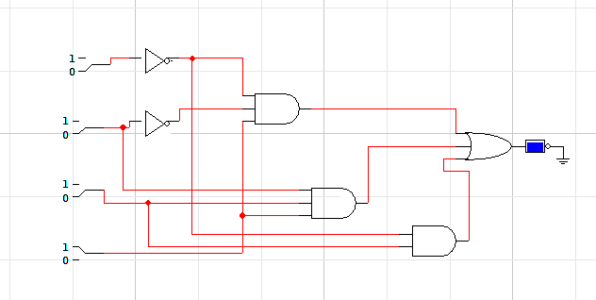

For A=B:
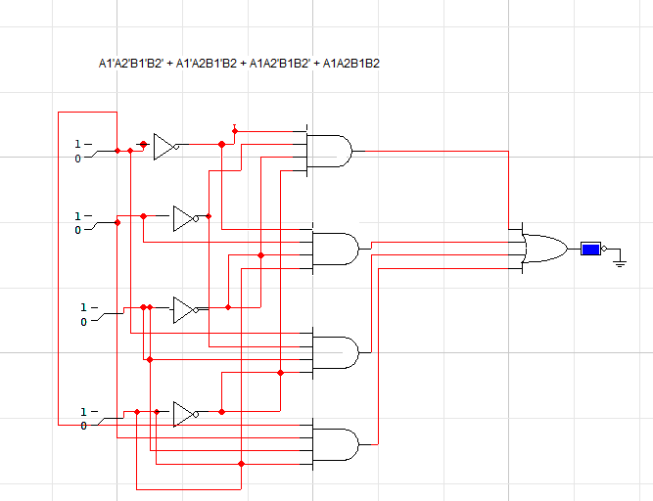

For A>B:
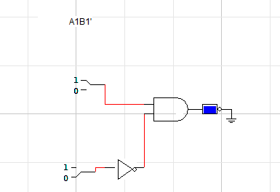

Task#2:
Logic Circuit Diagram:
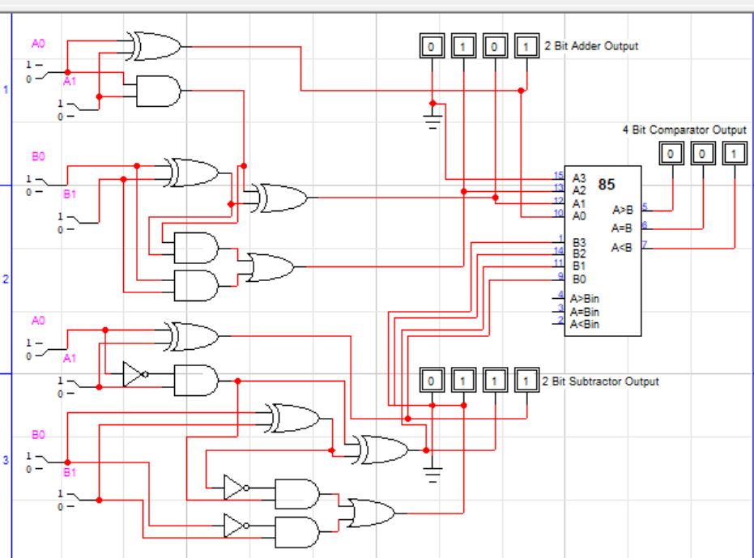

Task#3:
I found this question more complicated !

